**New UNI usage in pools**

When users think of using uniswap as a way to earn LP fees, the main problem(aside from gas fees in ETH) is *Impermanent loss(1).* New studies have shown that around 50% of all liquidity providers are incurring in negative returns(2).

At the moment, there is no way to escape this kind of problem(it is not a hidden problem, since it is fully disclosed upfront), but when thinking long term, if liquidity were to migrate to a place where this types of issues are solved, Uniswap would lose one of the biggest assets(besides their team), their liquidity depth.

Having that problem in mind, the idea proposed is to add the UNI token, some usage besides Governance or the oracle idea that never materialized.

How would this work?

Imagine when you are supplying liquidity to a pair, that you were presented an option to be insured against IL.

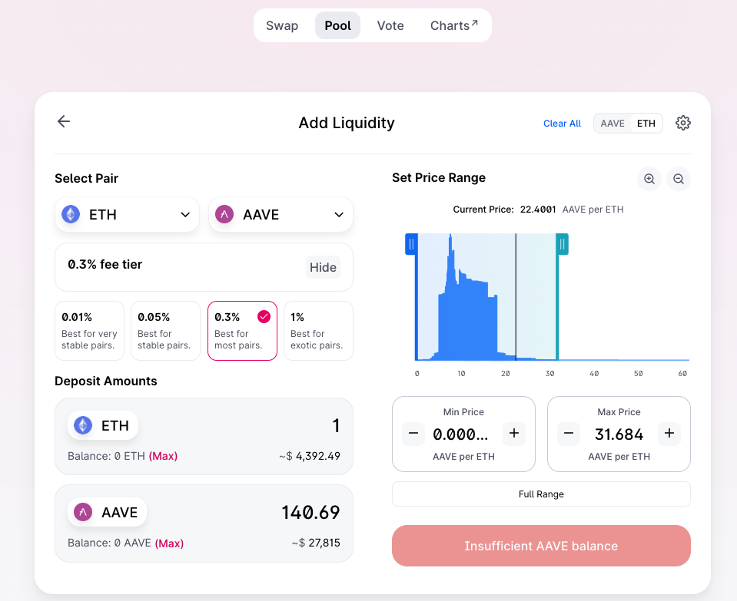

*Regular add liquidity page

You could choose the range in which you would like to be insured. This could be payed in UNI tokens(when the price gets to the range selected by the depositor, it triggers a sell from UNI to the token needed to rebalance the position).The depositor should manage his position, checking if their UNI balance is too low, having the chance to add new liquidity to keep their position protected or go on like the product is running now, with no insurance.

This would give the UNI token a new function. Impermanent loss is a difficult topic to understand so the UX/UI of this feature should be as simple and as clear as possible.

If this feature were to be added to the product, I believe it would need to re-engineer some parts of the product, so this proposal is aiming towards a V4 version of UNiswap.